IBM Cloud Private 3.1.2

**Lab Exercise #2**

**IBM Cloud Private CommandLine Walkthrough**

Duration: 30 mins

TABLE OF CONTENTS

2 Login to ICP 3

2.1 Overview 3

2.2 Access your ICP Instance 3

2.3 Login to your ICP Console 3

2.4 Getting Started 5

2.5 Install ICP command Line 5

2.5.1 Install IBM Cloud Private CLI 9

2.5.2 Install Kubernetes CLI 9

2.5.3 Install Helm CLI 9

2.5.4 Install Istio CLI 9

2.5.5 Install Calico CLI 10

3 Cloudctl commands 11

3.1 Cloudctl version 11

3.2 Cloudctl api 11

3.3 Cloudctl login 11

3.4 Cloudctl logout 12

3.5 Cloudctl target 13

3.6 Cloudctl help 13

4 kubectl commands 15

4.1 Overview of kubectl 15

4.1 kubectl get 15

4.2 kubectl logs 15

4.3 kubectl describe 16

4.4 kubectl explain 16

5 helm commands 18

5.1 Overview 18

5.2 Helm version 18

5.3 Helm repo – add, list, remove, update and index chart repositories 18

5.4 Helm search – search for charts 18

5.5 Helm list – list releases of charts 19

# Login to ICP

## Overview

In this lab exercise, you explore the IBM Cloud Private Command Line.

## Access your ICP Instance

Using your ICP environment, log in as <username> with the password <password>

## Login to your ICP Console

If you are not already logged in to the ICP Admin Console from a previous exercise, open a browser and navigate to [https://174.37.17.188:8443](https://174.37.17.188:8443/)

Log in by using username: <username> and password: <password>

## Getting Started

The **Welcome** page displays after you successfully log in.

## Install ICP command Line

You can install and use the IBM Cloud Private command line interface (CLI) to manage one or multiple clusters.

After you install IBM Cloud Private, you can install the CLI on Windows™, Linux®, or macOS.

From the IBM Cloud Private management console, click **Menu** > **Command Line Tools** > **Cloud Private CLI** to download the installer with a curl command.

Copy and run the curl command for your operating system, then continue the installation procedure:

Choose the curl command for the applicable operating system.

Use the ICP Command Line installation guide from the IBM Knowledge Center.

1. Download the command line tools from ICP Console.

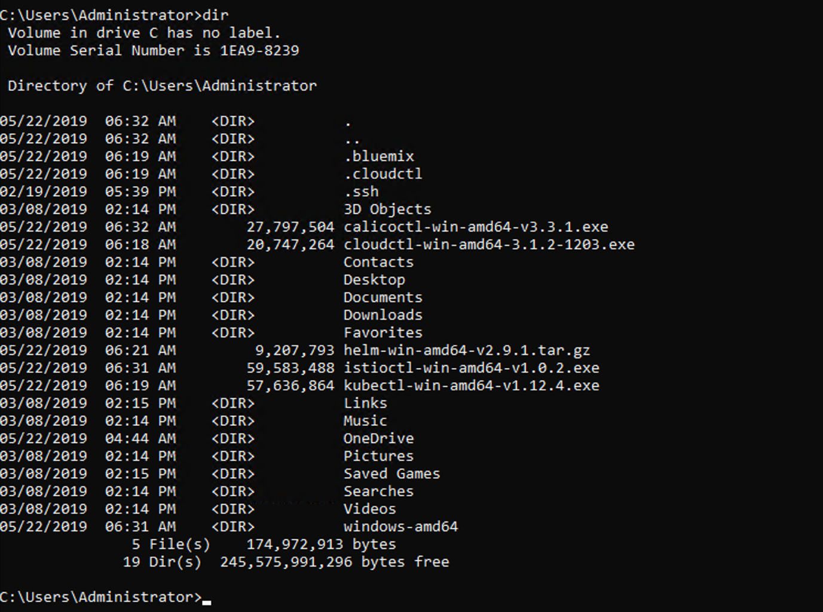

Extract helm installer

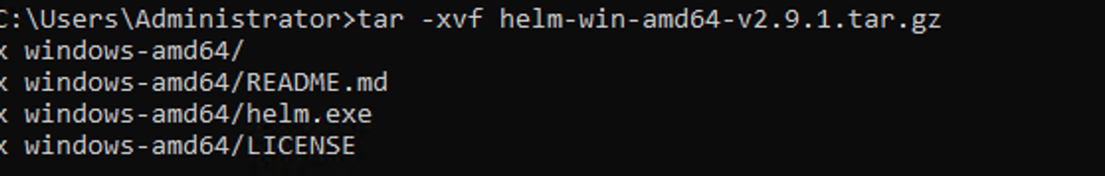

Rename the files

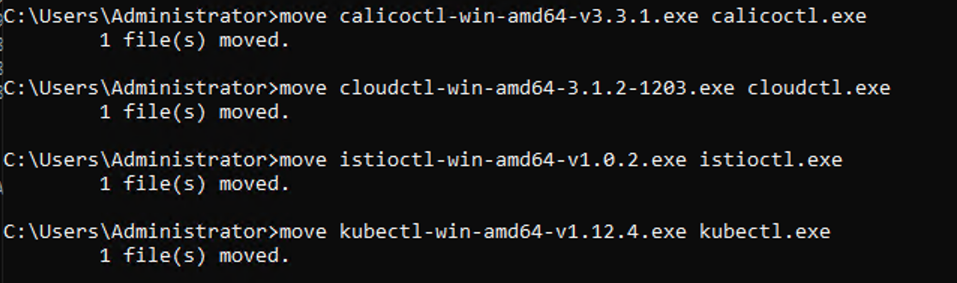

Rename the executables –



Create an icp folder -



Move the files to icp folder

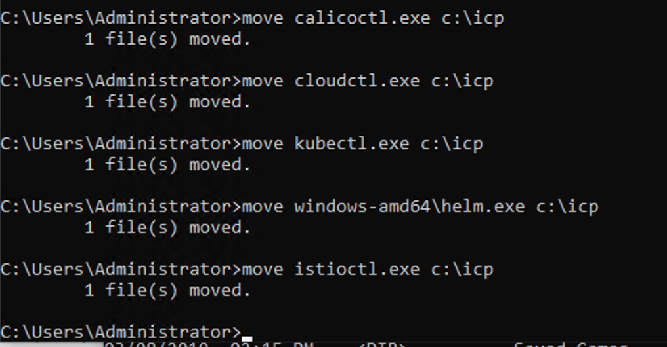

Add the ICP folder in the path variable



**Execute the following command to check installations –**

kubectl version

cloudctl version

helm version

# Cloudctl commands

## Cloudctl version

Check CLI and API version compatibility.

cloudctl version

## Cloudctl api

View the API endpoint and API version for the service.

cloudctl api

**API Endpoint:** https://mycluster.icp:8443

**API Version:** v1

**Skip SSL Validation:** true

## Cloudctl login

Log user in.

cloudctl login [-a CLUSTER_URL] [-u USERNAME] [-p PASSWORD] [-c ACCOUNT_ID or ACCOUNT_NAME] [-n namespace] [--skip-ssl-validation]

WARNING: It is best practice to avoid providing your password in the command line option. Your password might be visible to others and might be recorded in your shell history.

EXAMPLE:

cloudctl login

To interactively provide your user name and password, omit the user name and password options.

cloudctl login -u name@example.com -p pa55woRD

Specify your username and password as arguments.

cloudctl login -u name@example.com -p "my password"

Use quotation marks (") around passwords that have spaces.

cloudctl login -u name@example.com -p "\"password"\"

If your password contains quotation mark characters (“), use backslash characters (\) to escape them.

PARAMETERS:

-a value The URL that you use to access the management console, such as https://<ip_address>:8443.

-u value Username

-p value Password

-c value Account ID or name

-n value Name of a namespace

--skip-ssl-validation Bypass SSL validation of HTTP requests. This option is not recommended.

cloudctl login -a [https://172.16.70.57:8443](https://172.16.70.57:8443/)

Username**>** admin

Password**>**

Authenticating...

**OK**

Targeted account **mycluster Account (id-mycluster-account)**

Select a namespace:

1. cert-manager

2. default

3. ibmcom

4. istio-system

5. kube-public

6. kube-system

7. platform

8. services

Enter a number**>** 2

Targeted namespace **default**

**Configuring kubectl ...**

**Property "clusters.mycluster" unset.**

**Property "users.mycluster-user" unset.**

**Property "contexts.mycluster-context" unset.**

**Cluster "mycluster" set.**

**User "mycluster-user" set.**

**Context "mycluster-context" created.**

**Switched to context "mycluster-context".**

**OK**

**Configuring helm: /Users/surbhi/.helm**

**OK**

## Cloudctl logout

Log user out.

cloudctl logout

Logging out...

**OK**

## Cloudctl target

Set or view the targeted namespace.

cloudctl target [-n NAMESPACE]

PARAMETERS:

--namespace value, -n value Name of the namespace to target

## Cloudctl help

It provides the various options with cloudctl commands.

cloudctl --help

NAME:

cloudctl - A command line tool to interact with IBM Cloud Private

USAGE:

[environment variables] cloudctl [global options] command [arguments...] [command options]

VERSION:

3.1.1-973+c18caee2d82dc45146f843cb82ae7d5c28da7bc7

COMMANDS:

api View the API endpoint and API version for the service.

catalog Manage catalog

cm Manage cluster

config Write default values to the configuration.

iam Manage identities and access to resources

login Log user in.

logout Log user out.

plugin Manage plugins

pm Manage passwords

target Set or view the targeted namespace.

tokens Display the oauth tokens for the current session. Run `cloudctl login` to retrieve the tokens.

version Check CLI and API version compatibility.

help

Enter 'cloudctl help [command]' for more information about a command.

ENVIRONMENT VARIABLES:

CLOUDCTL_COLOR=false Do not colorize output

CLOUDCTL_HOME=path/to/dir Path to config directory

CLOUDCTL_TRACE=true Print API request diagnostics to stdout

CLOUDCTL_TRACE=path/to/trace.log Append API request diagnostics to a log file

GLOBAL OPTIONS:

--help, -h Show help

# kubectl commands

## Overview of kubectl

To manage Kubernetes clusters and IBM Cloud Private you can use the kubectl commands. In this section we show you some of the kubectl commands that would help you manage your cluster and IBM Cloud Private Installation.

## kubectl get

root@vicp312-master:~# kubectl get pods

NAME READY STATUS RESTARTS AGE

audit-logging-fluentd-ds-6fvqt 1/1 Running 0 36d

audit-logging-fluentd-ds-dbdwf 1/1 Running 0 36d

audit-logging-fluentd-ds-rtxfv 1/1 Running 0 36d

audit-logging-fluentd-ds-vmckn 1/1 Running 0 36d

auth-apikeys-r8hj4 1/1 Running 0 36d

auth-idp-2d8gc 4/4 Running 1 43h

auth-pap-4b5n5 2/2 Running 0 36d

auth-pdp-v264t 2/2 Running 0 36d

calico-kube-controllers-69c9dc655d-f7lj9 1/1 Running 0 36d

calico-node-6xdx5 2/2 Running 0 36d

## kubectl logs

The kubectl logs command shows the logs of a resource or a pod. This command is useful when troubleshooting an application and when you need more information about it.

kubectl logs mqapp-ibm-mq-0

{"host":"mqapp-ibm-mq-0","ibm_datetime":"2019-04-25T09:45:45.060Z","ibm_processId":"1","ibm_processName":"runmqserver","ibm_serverName":"TEST1","ibm_userName":"root","loglevel":"INFO","message":"Using queue manager name: TEST1","type":"mq_containerlog"}

{"host":"mqapp-ibm-mq-0","ibm_datetime":"2019-04-25T09:45:45.060Z","ibm_processId":"1","ibm_processName":"runmqserver","ibm_serverName":"TEST1","ibm_userName":"root","loglevel":"INFO","message":"CPU architecture: amd64","type":"mq_containerlog"}

{"host":"mqapp-ibm-mq-0","ibm_datetime":"2019-04-25T09:45:45.061Z","ibm_processId":"1","ibm_processName":"runmqserver","ibm_serverName":"TEST1","ibm_userName":"root","loglevel":"INFO","message":"Linux kernel version: 3.10.0-862.14.4.el7.x86_64","type":"mq_containerlog"}

{"host":"mqapp-ibm-mq-0","ibm_datetime":"2019-04-25T09:45:45.061Z","ibm_processId":"1","ibm_processName":"runmqserver","ibm_serverName":"TEST1","ibm_userName":"root","loglevel":"INFO","message":"Container runtime: kube","type":"mq_containerlog"}

## kubectl describe

The command kubectl describe is used to get information about pods, nodes, and other Kubernetes resources:

To get information on a specific node run:

kubectl describe nodes <nodename>

To get information on a specific pod run:

kubectl describe pods/<podname>

To get information on all pods run:

kubectl describe pods

## kubectl explain

Get documentation of various resources. For instance, pods, nodes, services, etc.

**kubectl explain [--recursive=false] [flags]**

kubectl explain pod

KIND: Pod

VERSION: v1

DESCRIPTION:

Pod is a collection of containers that can run on a host. This resource is

created by clients and scheduled onto hosts.

FIELDS:

apiVersion <string>

APIVersion defines the versioned schema of this representation of an

object. Servers should convert recognized schemas to the latest internal

value, and may reject unrecognized values. More info:

https://git.k8s.io/community/contributors/devel/api-conventions.md#resources

kind <string>

Kind is a string value representing the REST resource this object

represents. Servers may infer this from the endpoint the client submits

requests to. Cannot be updated. In CamelCase. More info:

https://git.k8s.io/community/contributors/devel/api-conventions.md#types-kinds

metadata <Object>

Standard object's metadata. More info:

https://git.k8s.io/community/contributors/devel/api-conventions.md#metadata

spec <Object>

Specification of the desired behavior of the pod. More info:

https://git.k8s.io/community/contributors/devel/api-conventions.md#spec-and-status

status <Object>

Most recently observed status of the pod. This data may not be up to date.

Populated by the system. Read-only. More info:

https://git.k8s.io/community/contributors/devel/api-conventions.md#spec-and-status

# helm commands

## Overview

The Helm package manager for Kubernetes.

## Helm version

helm version --tls

Client: &version.Version{SemVer:"v2.9.1", GitCommit:"20adb27c7c5868466912eebdf6664e7390ebe710", GitTreeState:"clean"}

Server: &version.Version{SemVer:"v2.9.1+icp", GitCommit:"420a6e6c4e8420efba6ea5c2eba846bdc9a086c1", GitTreeState:"clean"}

## Helm repo – add, list, remove, update and index chart repositories

This command consists of multiple subcommands to interact with chart repositories.

It can be used to add, remove, list, and index chart repositories

Helm repo add a chart repository

*helm repo add [flags] [NAME] [URL]*

**<Don’t add on this instance>**

Helm list chart repositories

*helm repo list [flags]*

helm repo list

NAME URL

stable https://kubernetes-charts.storage.googleapis.com

local http://127.0.0.1:8879/charts

incubator https://kubernetes-charts-incubator.storage.googleapis.com/

## Helm search – search for charts

Search reads through all of the repositories configured on the system and looks for matches.

helm search [keyword] [flags]

helm search

NAME CHART VERSION APP VERSION DESCRIPTION

incubator/artifactory 5.2.1 5.2.0 DEPRECATED Universal Repository Manager support...

incubator/aws-alb-ingress-controller 0.1.8 v1.1.2 A Helm chart for AWS ALB Ingress Controller

incubator/azuremonitor-containers 0.6.0 4.0.0-0 Helm chart for deploying Azure Monitor containe...

incubator/burrow 0.3.3 0.17.1 Burrow is a permissionable smart contract machine

incubator/buzzfeed-sso 0.0.1 1.1.0 Single sign-on for your Kubernetes services usi...

incubator/cassandra 0.12.2 3.11.3 Apache Cassandra is a free and open-source dist...

incubator/cassandra-reaper 0.2.0 1.3.0 Reaper is a centralized, stateful, and highly c...

incubator/chartmuseum 1.1.1 0.5.1 Helm Chart Repository with support for Amazon S...

incubator/check-mk 0.2.1 1.4.0p26 check_mk monitoring

incubator/cockroachdb 0.1.1 CockroachDB Helm chart for Kubernetes.

incubator/common 0.0.5 0.0.5 Common chartbuilding components and helpers

helm search mongo

NAME CHART VERSION APP VERSION DESCRIPTION

incubator/mongodb 0.1.1 MongoDB Helm chart for Kubernetes.

incubator/mongodb-replicaset 0.2.0 NoSQL document-oriented database that stores JS...

stable/mongodb 5.17.0 4.0.9 NoSQL document-oriented database that stores JS...

stable/mongodb-replicaset 3.9.4 3.6 NoSQL document-oriented database that stores JS...

stable/prometheus-mongodb-exporter 2.1.0 v0.7.0 A Prometheus exporter for MongoDB metrics

stable/unifi 0.4.2 5.10.19 Ubiquiti Network's Unifi Controller

## Helm list – list releases of charts

This command lists all of the releases.

By default, it lists only releases that are deployed or failed. Flags like ‘–deleted’ and ‘–all’ will alter this behavior. Such flags can be combined: ‘–deleted –failed’.

$ helm list --tls

NAME REVISION UPDATED STATUS CHART NAMESPACE

acedemo 1 Tue Jan 22 12:42:50 2019 DEPLOYED ibm-ace-dashboard-dev-1.0.0 default

anand-qm1 2 Wed May 1 12:32:09 2019 DEPLOYED ibm-mqadvanced-server-dev-3.0.1 default

audit-logging 1 Fri Dec 21 13:39:19 2018 DEPLOYED audit-logging-3.1.1 kube-system

auth-apikeys 1 Fri Dec 21 13:31:25 2018 DEPLOYED auth-apikeys-3.1.1 kube-system

auth-idp 1 Fri Dec 21 13:31:20 2018 DEPLOYED auth-idp-3.1.1 kube-system

auth-pap 1 Fri Dec 21 13:31:29 2018 DEPLOYED auth-pap-3.1.1 kube-system

auth-pdp 1 Fri Dec 21 13:31:33 2018 DEPLOYED auth-pdp-3.1.1 kube-system

calico 1 Fri Dec 21 13:28:16 2018 DEPLOYED calico-3.1.1 kube-system

catalog-ui 1 Fri Dec 21 13:38:07 2018 DEPLOYED icp-catalog-chart-3.1.1 kube-system

cert-manager 1 Fri Dec 21 13:29:26 2018 DEPLOYED ibm-cert-manager-3.1.1 cert-manager

custom-metrics-adapter 1 Fri Dec 21 13:38:42 2018 DEPLOYED ibm-custom-metrics-adapter-3.1.1 kube-system

heapster 1 Fri Dec 21 13:37:53 2018 DEPLOYED heapster-3.1.1 kube-system